**Understanding broadband**

|  |  |
| --- | --- |
| **Fibre To the Cabinet (FTTC)**  Copper wiring from premises to cabinet. This is the most common type of fibre optic home broadband | **Fibre To the Premises (FTTP)**  Fibre wiring all the way from, premises to exchange. Full fibre broadband, not as common as FTTC |

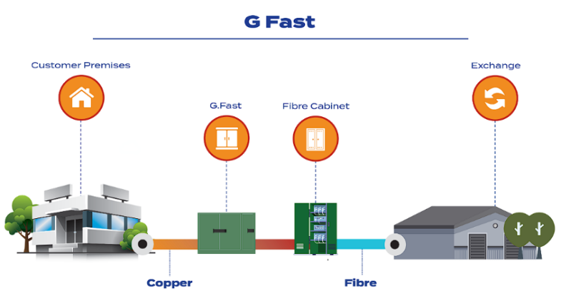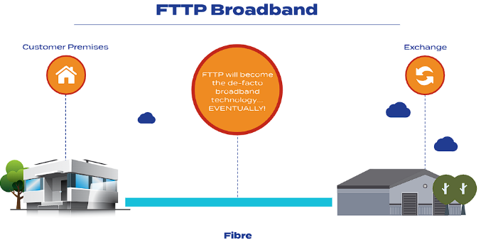

|  |  |
| --- | --- |
| **Key points:**   * Internet speeds are not as fast or reliable * Speeds tend to range from 40 - 80Mbps * Download speeds tend to be much faster than upload speeds * Great availability, 90% of premises have access * Line rental costs apply | **Key points:**   * Very fast and reliable full fibre broadband * Speeds can range from 150-1000Mbps and even higher * Much faster upload speeds, you can get symmetrical upload & download * Availability is currently limited, it’s still being introduced * Doesn't require phone line rental |
|  |  |

**Project Gigabit**

Project Gigabit is the UK government's national mission to deliver lightning-fast, reliable broadband for everyone1. It is a £5 billion program that targets hard-to-reach communities, ensuring they have access to gigabit-capable broadband.

Links:

UKGOV - [Government launches new £5bn ‘Project Gigabit’ - GOV.UK](https://www.gov.uk/government/news/government-launches-new-5bn-project-gigabit)

BBC - [Project Gigabit: Seven counties to get 'lightning fast' broadband](https://www.bbc.com/news/uk-england-68209712)