**YouFibre**

YouFibre is a fast-growing broadband provider dedicated to delivering ultrafast, reliable, and affordable internet services. With a mission to revolutionize connectivity, YouFibre specializes in full fibre broadband, offering speeds of up to 10Gbps to meet the demands of modern digital lifestyles. Combining cutting-edge technology with exceptional customer service, YouFibre aims to make high-speed internet accessible to all

**Features**



**Unique selling point**

Youfibre sets itself apart by focusing on its customer service, ensuring each customer is fully heard and completely satisfied. They now boast 4.7 stars on Trustpilot well ahead of other competitors.

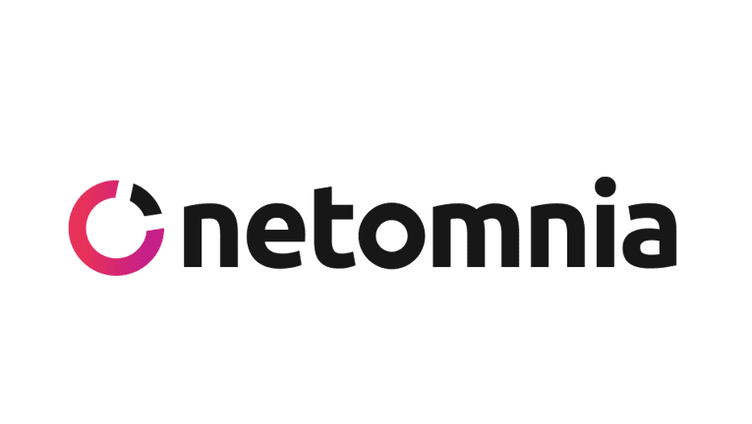

Netomnia is a wholesale fibre infrastructure provider that designs, builds, and maintains the physical fibre-optic network for Youfibre. YouFibre operates as an Internet Service Provider (ISP) that leverages Netomnia's network infrastructure to provide internet.

This collaboration allows YouFibre to focus on delivering exceptional customer service and affordable internet packages, while Netomnia concentrates on expanding and maintaining the underlying network.